公務員事務局法定語文事務部
OFFICIAL LANGUAGES DIVISION, CIVIL SERVICE BUREAU

文訊
WORD POWER

第二十二期 二零零六年一月 Issue No.22 January 2006

Protectors and Messengers
Animals as Cultural Symbols

Animals have been used as cultural symbols since the Stone Age. In many ancient civilisations, animals were symbols of sanctity and prophetic knowledge. In ancient Egypt, such animals as cats, bulls and crocodiles were regarded as sacred. Awe of their abilities — such as speed and flight — stimulated the notion of beasts as superior to humans, and hence the widespread practice of totem worship.

A particular animal may stand for similar qualities in different cultures. The dove is a universal symbol of peace, whereas the swan always represents grace and beauty. However, differences in cultural and aesthetic heritage have in some cases created entirely different images of an animal to different peoples. To the Chinese, the tortoise is a symbol of longevity. In the West, the tortoise carries no such cultural significance. It is noted more for its slow motion and thus lack of vitality.

In the Celtic (Scottish, Irish and Welsh) cultures, cattle represent fertility. Similarly, in India, the bull represents fertility and the masculine principle in nature. For the Hindus, the cow is the most sacred animal. In Chinese society, cattle symbolise diligence and strength.

While the Chinese admire horses for their speed and virility, they are important icons of power, wealth and status in many Western societies, e.g. the German and the Irish. In the old days, horses, as objects of veneration, were closely associated with many divinities. In Greek mythology, Apollo’s heavenly chariot was pulled across the sky by a white horse. In Scandinavian mythology, the mount of Odin, the creator of the world, was an eight-legged horse which could traverse either land or sea.

To the Chinese, the pig is a symbol of fecundity and prosperity. In ancient Celtic tradition, boars represented not only fertility and wealth, but also the spirit of aggression and invincibility in war. Thus they were frequently used as helmet crests — a boar-crested helmet both protected the wearer and made him frightening to look at.

In Irish and Welsh literature, stags are associated with the wild, and with speed and strength. They are also intermediaries between the gods and living humans. To the Chinese, the stag is a symbol of official position, because the words for “deer” and “officialdom” sound the same in Chinese. In a similar vein, bats symbolise auspice and happiness in Chinese tradition, purely because the Chinese word for “bat” sounds the same as the word for “felicity”. As we know from the vampire legends, bats in the West are perceived as sinister and associated with bad omens.

Birds, like land animals, are favourite symbols in many cultures. In times past, birds, marked by their powers of flight and their ability to sing, were seen as messengers from the supernatural world. People in both China and the West agree in their perceptions of the raven. Ravens are considered birds of ill omen, probably because of their black plumage and harsh squawks, as well as their propensity for eating the flesh of dead animals and humans. In the vernacular tales of Ireland, the raven was associated with combat and destruction. Thus it was a popular motif on armour and weapons. A raven-adorned helmet dating to the third or second century BC was clearly designed to terrify opponents as the warrior would appear much more fearsome with the raven perched on his head.

The Chinese also interpret the appearance of owls as a bad omen. It is their silent, ghostly flight and eerie call that make them frightening. Interestingly, in Western societies, many contradictions exist among traditional perceptions of the owl. Owls are cultural symbols of both dark mystery and good fortune.

Since the time of the ancient Greeks, the owl, originally as the symbol of Athene, has been a symbol of intelligence and learning, and considered an omen of good fortune and victory. In Aesop’s Fables, the owl is portrayed as alert and astute. It knows that the nets for bird catching are made of flax and encourages the birds to pluck up the flaxseeds sown. In Germany, an owl’s appearance is thought to predict the safe birth of a child.

Paradoxically, in many folk and fairy tales, owls are often present at witches’ gatherings (Harry Potter has a very special snowy white owl called Hedwig). Witches, too, may appear as owls. The owl has been associated with bad omens and given names like “bird of death” and “bird of sorrow”. Such a mixed image, which embodies the projection of both man’s hopes and fears, must amuse the unperturbedly wise owl.

Usage & Abusage

The Legacy of Mrs Malaprop

When someone misuses a word, the result can induce hilarity, like when a former Chicago mayor said when faced with a throng of protesters, “The police are not here to create disorder, they’re here to preserve disorder”. An amusing misuse of a word, especially when mistaking a word for another resembling it, is called a malapropism.

Malapropism comes from the name of Mrs Malaprop, a character in Richard Brinsley Sheridan’s comedy, The Rivals (1775), whose name was in turn derived from the French mal à propos meaning “inappropriate”. Mrs Malaprop is a wonder. She is blithely unaware that she “selects words so ingeniously misapplied without being mispronounced”. Here are some examples from her observations: “She’s as headstrong as an allegory on the banks of the Nile” (i.e. “alligator”) and “He is the very pineapple of politeness” (i.e. “pinnacle”).

Mrs Malaprop has left an enduring legacy in the English speaking world. Her ancestry goes back to Sergeant Dogberry in Much Ado About Nothing (1599), one of Shakespeare’s greatest comic inventions. His quotable quotes include “Comparisons are odorous” (i.e. “odious”) and “Our watch, sir, have indeed comprehended two auspicious persons” (i.e. “apprehended”; “suspicious”).

It appears “comprehension” and “apprehension” are indeed easily confusable. Four centuries later, a celebrity baseball team manager declared “It is beyond my apprehension”. Some more genuine malapropisms gathered from across the Internet: “He’s a wolf in cheap clothing” (i.e. “sheep’s”) and “Their father was some kind of civil serpent” (i.e. “servant”) — a Freudian slip?

There are lots of potential malapropisms that may arise from words of similar appearance, e.g. “stationary”/“stationery”, “alternate”/“alternative”, and “complement”/“compliment”, to name just a few. While we laugh at others’ ludicrous misuse of words, it is better to keep in mind that embarrassment will be the more likely effect if it is we who have made the blunder. To play safe, if we have the slightest doubt, it is better to look up the word in a dictionary. Homer sometimes nods, right?

談文說字

隨物賦形

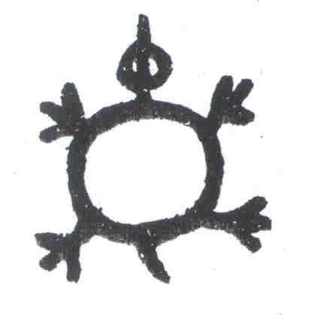這個圖形是否似曾相識？遙記炎炎夏日的課堂上，正當視線開始模糊，老師的講書聲漸次微弱之際，只要赫然瞥見同學背上給貼上了一幅，精神便會為之一振，睡意全消。殊不知這個圖像大有來頭，跟遠古金文的“龜”字如出一轍呢。

是典型的象形字。文字源於圖畫，世界上很多古文字，例如漢字和埃及的古文字，都是象形文字，活像一幅幅圖畫，就拿“龜”字來說吧。“龜”字本來就是畫一隻龜的形狀，甲骨文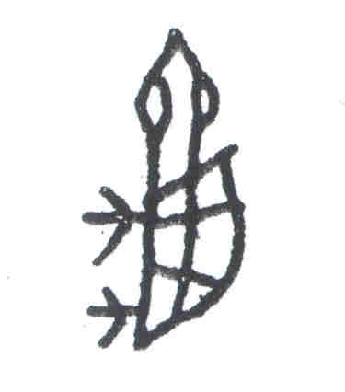象龜的側視形狀，金文則象龜頂視之形。不少古文字漸漸演變成拼音符號，而少數漢字仍保存象形的痕迹。

漢字的發展歷經三千多年，其間漢字的形體經過了多次演變，主要的字體有：

甲骨文 商朝刻在龜甲和獸骨上的文字。
金文 商周時期刻鑄在青銅器上的文字，又稱鐘鼎文。
小篆 秦始皇統一天下後，整理前朝文字而成的一種標準字體。
隸書 漢朝通用的文字，是古文字演變為今文字一個重要的轉折點。
楷書 自漢末通行至今的一種字體，特點是形體端正，筆畫平直。

今天我們常用的楷書已不像圖畫了，但由圖畫演變而來的痕迹，還依稀可辨。只要加一點想像，輔以簡單的解說，不難看出很多漢字都源出於維肖維妙的圖畫。

大家可有興趣考考自己的眼力，辨認一下表中八個出自甲骨文和金文的漢字，演變成楷書哪些字形？（答案見本欄右下角。）

 | 一 | 二 | 三 | 四 | 五 | 六 | 七 | 八
甲骨文 | 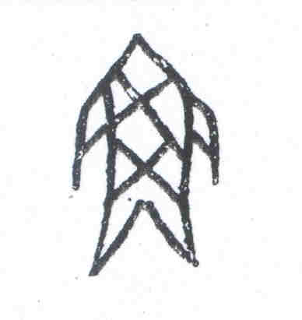 | 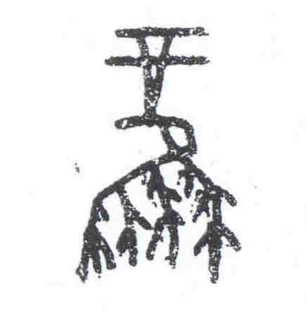 | 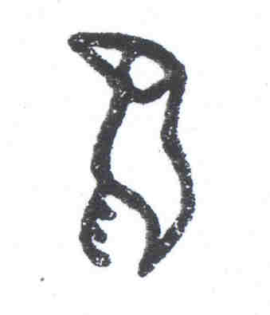 | 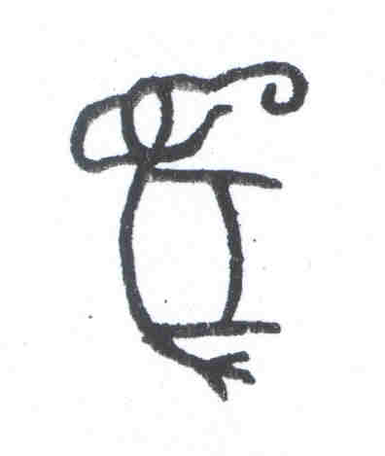 | 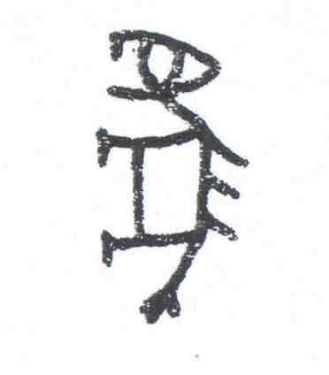 | 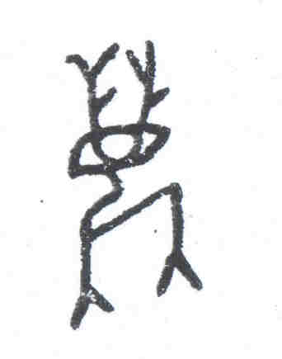 | 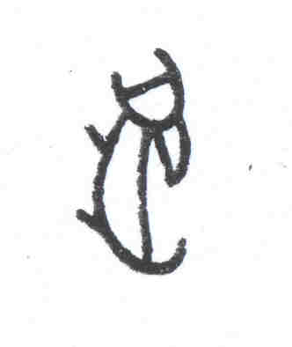 | 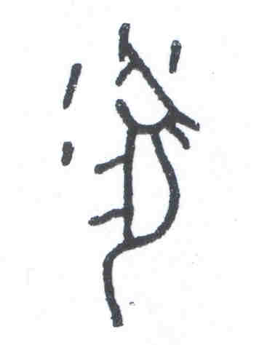
金文 | 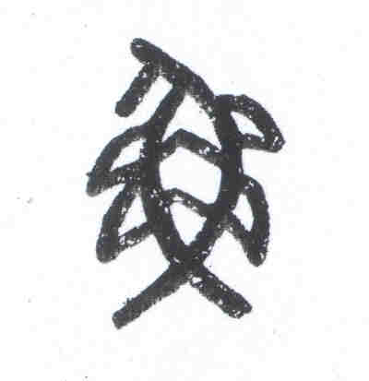 | 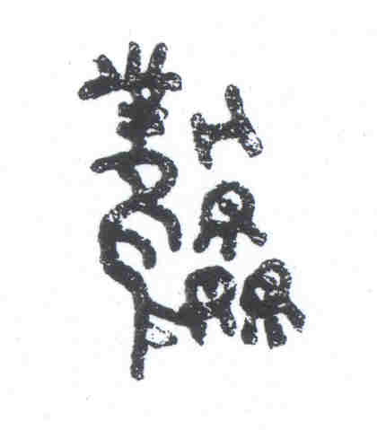 | 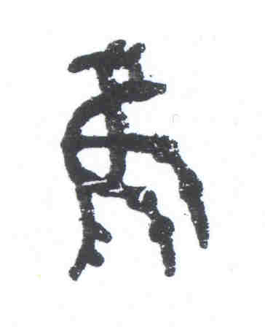 | 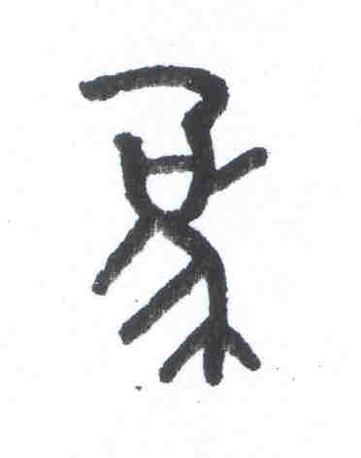 | 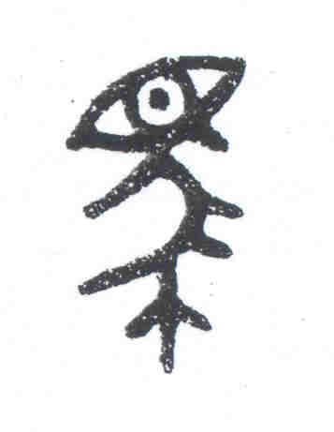 | 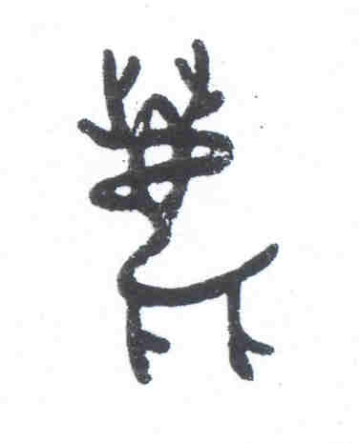 | 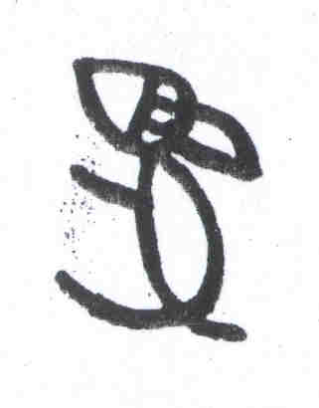 | 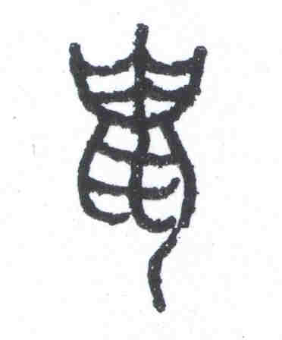

答案

一 魚 象一尾魚，魚頭、身、鱗、鰭俱全。
二 鳳 象羽冠長尾的鳥，特別突出美麗的尾翎。
三 鳥 象鳥側視之形，突出尖尖的鳥嘴和細細的鳥爪。
四 象 象長鼻巨齒的大象，突出大象寬厚的身軀。
五 馬 象長臉長鬃垂尾的馬。
六 鹿 象靈動跳脫的鹿，突出枝杈狀的角、大眼尖嘴，還有輕盈的鹿身。
七 兔 象長耳短腿短尾的兔子。
八 鼠 象尖嘴、利齒、弓背、短腿、長尾的老鼠之形。

一席話

動物與吉祥文化

影視及娛樂事務管理處
一級法定語文主任阮偉強

中國文物多有吉祥寓意。數千年前，我們的祖先已視某些動植物為吉祥物，甚至以龍、鳳、麒麟等為“瑞獸”。這種把動植物轉化為吉祥象徵的例子俯拾皆是，除了表達百姓對福澤祥瑞的期許，還在不知不覺間，引導人們以樂觀的心境面向不可知的未來。

先談一談瑞獸。中華民族自稱龍的傳人，以龍作為華夏的圖騰。《說文解字》對“龍”的解釋是“能幽能明，能細能巨，能短能長；春分而登天，秋分而潛淵”。龍的形態可謂變幻至極，玄妙無比。在遠古時代，龍已是地位崇高的靈獸，能行雲布雨，通靈變化，力量足以影響天下蒼生，因而成為帝王的象徵和標識。古代帝王奉為“真龍天子”，君王登基即位稱為登上“九五之尊”。所謂“九五”，即《易經‧乾卦》爻辭所描述“飛龍在天”的象徵。

談了龍自然要說鳳。按照《說文解字》的解說，鳳是神鳥，“見則天下大安寧”。鳳頭頂美麗羽冠，身披五彩翎毛，形態綜合了許多鳥類的特點。鳳是傳說中的“百鳥之王”，標誌吉祥、太平和政治清明。又因鳳見有奇珍異寶才會下凡，地位尊貴，遂成為皇后的象徵。後來民間百姓也以鳳為吉祥物。在傳統婚禮上，鳳成了新娘禮服和頭飾上的裝飾，代表吉祥喜慶。龍常與鳳合成一對，象徵夫婦，故有“龍鳳呈祥”之說。

還有一種叫“甪端”的神獸。據古書所載，¹甪端是獨角獸，鹿形、馬尾、四爪，日行一萬八千里，更兼通曉四夷語言，一張口便帶來福瑞，古人遂以此獸的形象做成香爐，當煙從獸嘴冒出來時，便成了祥瑞之煙。自春秋至今，香爐上的瑞獸全都是甪端，不少人還以為是麒麟呢。

回到現實世界，寓意吉祥的動物可真不少。例如以形影不離的鴛鴦祝願夫妻恩愛。古時獾也是夫妻和順的象徵。獾體形如狐狸，覓食時總是成雙成對，加上“獾”與“歡”諧音，兩隻獾在一起成了合獾（“合歡”），所以古人會把合獾玉雕送給新婚夫婦。

與獾一樣，蝙蝠因着名稱與“福”諧音而奉為吉祥物。中國吉祥文化很重視福祿壽三星。據《尚書》所云，福有五種，即壽、富、康寧、愛好美德和能得善終。蝙蝠的“蝠”與“福”同音，因此歷來代表福氣。古代流行五蝠圖案，寓意五福臨門。鹿自古已是吉祥動物，原本代表健康快樂。²按照《說文解字》，“祿”（意指官祿財富）的音義均來自“鹿”，鹿遂成為祿的象徵。

另外，古漢語“羊”通“祥”。³“羊”既與“祥”諧音，又與“陽”同音，羊便成為吉祥光明的象徵。古器物銘文多刻有“吉羊”二字。《漢元嘉刀銘》：“宜侯王，大吉羊”；《博古圖》漢《十二辰鑑》：“辟除不羊”，皆以“羊”為“祥”。新春賀詞“三羊啟泰”，本是“三陽啟泰”，源於《易經》以正月為《泰》卦，而《泰》卦有三個陽爻，寓意冬去春來，陰消陽長，有吉祥亨通之象。中國傳統吉祥圖案以三羊代表這個意象。商代出土文物有雙羊尊，⁴ 漢墓中有羊形鎮墓獸，藏族更將羊頭懸於門外，以鎮宅辟邪。

中國傳統文化也很重視鯉魚，因為“鯉”與“利”諧音，“魚”又與“餘”同音，因此鯉魚象徵財利有餘。因着“鯉躍龍門化成龍”的傳說，鯉魚又與進第和功名拉上關係。唐代詩人章孝標有一首《鯉魚》詩：“眼似真珠鱗似金，時時動浪出還沉，河中得上龍門去，不嘆江湖歲月深”，以鯉魚之力爭上游，比喻只要自強不息，一朝出人頭地，經歷多少艱辛也是值得的。

世上每個民族都有吉祥文化，背後富含精神和心靈意義。人們祈福致祥，託物寓意，給個人、家人燃點希望，增強自信。不論吉祥文化是否帶有迷信色彩，吉祥文化對個人心靈所起的調和作用，相信也是值得肯定的。

¹ “甪”粵音“路”，“甪端”見於《宋書‧符瑞志》和《續通志》。
² 《埤雅》云：“鹿者仙獸，常自能樂性”。
³ 古漢語沒有“祥”字，遂以“羊”字假借。
⁴ “尊”為容酒器。

鶴壽千歲，以極其游；蜉蝣朝生而暮死，而盡其樂。
劉安

Word for Word

Animals in Human Language

Animals have been a part of people’s lives for thousands of years. Many pre-industrial rural societies depended on domestic beasts for their livelihood, on wild creatures for hunting and on horses for warfare. Today, many animals, like dogs and cats, have become people’s pets and cherished family members. This age-old symbiotic relationship between animals and humans has given rise to a host of expressions involving animals in the languages of all nations.

Animals have gained established connotations over time. People associate their feelings and emotions with various animals. Many animals have become symbols of different personality traits. Sayings like “as cunning as the fox” appear in many languages. In English, an extremely happy person is often described as “like a dog with two tails” or “as happy as a lark”.

Idioms featuring the wolf reflect similar perceptions of this animal in China and the West. The wolf has long been (mis)represented as sly, greedy and ferocious in both the English and Chinese languages, hence many derogatory idioms involving the wolf. English idioms include “to throw someone to the wolves” (出賣朋友), “to cry wolf” (狼來了) and “a wolf in sheep’s clothing” (披着羊皮的狼); there are also Chinese idioms denouncing a person’s rapacity, cruelty and usurpation of power in “如狼似虎”, “狼心狗肺” and “豺狼當道” respectively.

Thanks to different historical and cultural backgrounds, the connotations of animal words in one language do not necessarily coincide with those in another. The Chinese term “走狗” (lackey) was once improperly translated into English as a “running dog”, which simply means a dog that is running and contains no derogatory sense. While the dog in the West is generally regarded as man’s best friend, in China traditionally dogs had low status since they served only as guard dogs in rural communities. This lack of affection towards dogs is reflected in the language. Chinese idioms referring to dogs all present a negative image of the animal like “狗眼看人低” (to act like a snob) and “狐羣狗黨” (a gang of scoundrels).

It is interesting to note that some mythological animals in the Chinese and Western cultures have been mistakenly matched. For example, both 龍 and the dragon are products of the human imagination, but that’s where their similarity ends. In Chinese tradition, 龍 is an all-powerful animal whose realm covers the sky and the sea. It has long been a symbol of auspice and majesty. Conversely, the dragon in Western legends is an evil monster that has wings and a long tail and breathes fire. Many Chinese would “望子成龍”, but its literal translation “to expect one’s son to become a dragon” might sound ridiculous to the English speaking people.

The appearances of 龍 and the dragon have little in common and they carry entirely different cultural connotations. Hence “亞洲四小龍” is properly turned into “the four tigers of Asia”. Yet “the Year of 龍” is still rendered as “the Year of Dragon” and “舞龍” as “dragon dance” in English. To convey accurately the positive image of 龍 in English, why not transliterate “龍”as “long” following the examples of “kung fu”, “tai chi” and “wok”? In a similar vein, “鳯” in Chinese denotes an imaginary bird vastly different from the phoenix. To translate “鳯” as “phoenix” is another example of a mismatch.

Sometimes different animals are employed to put across a similar message in both Chinese and English, such as “a black sheep” (害羣之馬) and “to talk horse” (吹牛). For each of the following idioms, would you like to try your hand at finding a similar Chinese expression inspired by the animal world? (Answers at the bottom of the page)

1. a rat in a hole
2. chicken-hearted
3. a donkey in a lion’s hide
4. neither fish nor fowl
5. to drink like a fish
6. crocodile tears

Answers

1. 甕中之鱉
2. 膽小如鼠
3. 狐假虎威
4. 非驢非馬
5. 牛飲
6. 貓哭老鼠假慈悲

It is not only fine feathers that make fine birds.
Aesop

Toolbox

British National Corpus

Does “impact” have a plural form? What are the verbs and prepositions that may collocate with it?

When we have doubts about the usage of a word or phrase, we may consult a dictionary or grammar book. Yet sometimes we are still not sure if we can say, for example, “significant impacts” or “the impact arising from...”. This is where a language corpus comes in useful. The British National Corpus (BNC), for instance, is a large corpus of modern English, with extracts from a wide variety of written and spoken materials. While a paid full version will provide users with a large database of real life examples, the simple search function is quite sufficient as a quick and handy reference to English usage. Visit this website: http://sara.natcorp.ox.ac.uk/lookup.html and enter the word or phrase you want to look up. It gives as many as 50 examples free of charge. In the case of “impact”, the BNC will tell you that it usually combines with the verbs “have”, “make” and “produce” and the prepositions “on” and “upon”. Examples are readily at hand for reference — and they show that “impact” can have a plural form.

Animals are such agreeable friends — they ask no questions, they pass no criticisms.
George Eliot

文化廣場

龍蛇混雜 雞犬相聞
十二生肖拉雜談

在中國社會，十二生肖無人不曉。十二生肖是傳統的紀年方法，既採用天干配地支紀年，又用十二地支各配一種動物，表示這一年的順序和名稱，即子鼠、丑牛、寅虎、卯兔、辰龍、巳蛇、午馬、未羊、申猴、酉雞、戌狗、亥豬。

生肖也叫屬相，所謂生肖，“生”指出生年，“肖”意指相似。根據傳統觀念，人在哪年出生就屬哪年的動物，如丙戌年又稱狗年，這一年出生的人便屬狗，性格會帶有狗忠心耿耿的特性。

生肖文化並非中國獨有，希臘、埃及、印度和中國四個文明古國都有十二生肖。希臘的十二生肖（十二獸曆）是牡牛、山羊、獅子、驢、蟹、蛇、犬、鼠、鱷、紅鶴、猿、鷹。埃及與希臘相似，只是將鼠換成了貓。印度與中國的生肖相差無幾，只是將虎換成了獅子。

十二生肖始於何時，源於何地，今已難於細考。至於十二生肖的起源，十二種動物按照什麼來排序，歷來眾說紛紜。一說是十二生肖源於遠古先民的十二獸紀曆法，這種紀曆法又與原始動物圖騰崇拜分不開。在物我不分、人獸雜處的遠古時代，先民在生存競爭中為求自身安全，往往敬奉某種動物，以祈保護，於是產生圖騰崇拜，並用圖騰動物為本族命名。其後逐漸用幾種常見的動物紀年，產生了十二屬相。

在神話傳說中，十二生肖的起源比較生動有趣。相傳，遠古時代軒轅黃帝要挑選十二種動物值日掌管時間。黃帝決定舉行一次動物賽跑，按比賽的名次排定順序。比賽開始了，牛跑得最快，可是老鼠蹦到了牛背上，到達終點時，老鼠又一蹦，搶先過了終點，於是得了第一名，值頭班。民間故事還講述老鼠怎樣和貓結怨，原來因為貓貪睡，囑咐老鼠比賽前叫醒他，豈料老鼠撇下了好朋友貓，自己去參賽，而且得了頭名，此後貓與鼠就世代為仇了。

十二生肖文化歷久不衰。歷代宮廷的銅鏡、民間的窗花、碑碣墓誌上都可以看到生肖的蹤影。生肖圖案、紋樣成為吉祥的象徵。時至今日，生肖依然是中國民間普遍流行的紀年符碼。每當新年伊始，這一年的生肖動物便成為吉祥物。取材自十二生肖的篆字、繪畫、書法、剪紙和春聯，豐富了文學藝術的內涵；不同地域的風俗習慣，也因生肖文化的浸染而更富姿采。

承蒙香港郵政署長慨允刊登生肖郵票圖像，謹此鳴謝。

驛站

容易混淆字詞辨析第二輯

漢字有些字形十分相近，加上讀音相同，平日下筆為文，一不留神便會混淆用錯，例如迥異還是迴異，藉口還是籍口，鬼鬼祟祟還是鬼鬼崇崇？做成跟造成的用法有何不同？如果大家也對此感到疑惑，《容易混淆字詞辨析》或許可派用場。

《容易混淆字詞辨析》第一輯在二零零四年出版。第二輯在去年十月出版，整理了四十組容易混淆的字詞，除了加以比較、辨析外，還加入配詞和造句示例，讓公務員同事更了解這些字詞的形、音、義，遣詞用字更準確。

舉例來說，臘和蠟字形相近，讀音相同，但意思截然不同。成語“味同嚼蠟”的意思是如同咀嚼白蠟一樣毫無味道，用以形容事情、文章或言辭枯燥乏味。如果誤寫成“味同嚼臘”，便變成咀嚼味道甚好的臘肉。“不恥”和“不齒”也是讀音相同，但意思剛好相反。“不恥”的意思是不以為羞恥；“不齒”則表示鄙視。成語“不恥下問”解作不認為向地位、學問不如自己的人請教為恥辱，形容虛心好學。一旦把“不恥下問”誤寫成“不齒下問”，便會變成不屑向人請教。“不齒某人所為”解作鄙視某人的所作所為，如果誤寫成“不恥某人所為”，意思就變成不認為某人的行為可恥。

《容易混淆字詞辨析》第二輯還附有容易讀錯字詞一覽表，列出一些容易讀錯的常用字詞，註明字詞正確的粵音之餘，還有簡略的誤讀辨析。

《容易混淆字詞辨析》第一、二輯已上載公務員事務局法定語文事務部內聯網（http://ola.ccgo.hksarg），同事可以“非註冊用戶”登入，然後到資料庫內語文參考資料一欄瀏覽或下載。

南腔北調

說好普通話
小錦囊三

在此嘮叨了兩期，談到要說好普通話，第一個竅門是以聽促說，然後是發音準確，就是說，按照普通話的語音標準，把每個音節的聲母、韻母、聲調發準。上期談了聲母，這期談談韻母。

韻母主要由元音構成，元音就是語音中響亮的聲音。要說韻母或者元音的發音原理，可以說上一大堆。不過，香港人學習普通話，韻母大概是難點相對少的一塊，所以在此只說說發好韻母須注意的三點。

第一，元音發音條件有三方面。首先是舌位的高低，即口腔開度，要做到拉開口腔，使得韻母發音響亮清晰。我們發舌面單元音如a、o等，往往口開得不夠大。打開口腔不僅僅是張開嘴巴，竅門在於發音時，支點在跟顴關節同水平的鼻子兩側，開始鍛鍊時，嘴唇稍咧開，像在微笑和略聳鼻子便可。在舌面單元音中，a的開口度最大，然後順序是其他展唇音o、e、i，最後順序是圓唇音u、ü，掌握好a的開口度，就能順勢找準其他幾個音的開口度。在此順帶一提，不管是聲母還是韻母，發音時用的絕對是柔勁，而不是死勁。其次是舌位的前後，我們的e音發不好，正是因為舌位的前後位置沒找對，竅門是在歸音時，舌頭略往後縮。最後是唇形的圓展，如u音，要發好，嘴唇得像用吸管時般運動和微微使勁兒。

第二，複韻母雖說只有一個發音響亮的主要元音，其他都是次要元音，發音輕短模糊，但不等於可以落掉其他元音。如“家”字，標音是jia，屬於後響複韻母，主要元音是a，但並不等於i的音就能吃掉，發音成了ja就不對。同時必須注意，別因為發了ji的音而令a的開口度不夠。記好了，複韻母的元音發音是一個不能少！

第三，前、後鼻韻母不分是香港人常見的通病，要區分其實非常簡單。發前鼻音如an、in歸音時，舌尖向上齒齦移動，在抵住上齒齦後停聲。發後鼻音如ang、ing歸音時，舌頭微微往下齶壓，最後舌根抵住軟齶停聲。

說韻母的竅門就此打住，下期會談聲調。

更正： 上期談到不要誤把翹舌音當成捲舌音時，說“普通話除了兒化音外，根本沒有任何捲舌音”，其實應為“普通話除了er元音和兒化音外，根本沒有任何捲舌音”。特此更正，如有誤導，謹此致歉。

牛刀小試

第二十一期《牛刀小試》遊戲答案

1. 絲綢之路 貫穿中亞內地，進而聯結歐洲的交通幹線。
2. 鴻臚寺 唐代朝廷接待各國使節和賓客的地方。
3. 李延年 融和中西音樂，創作新曲。
4. 葡萄 由張騫從西域傳入中原。
5. 梵文 對漢語切音的創造有啟迪之功。
6. 胡牀 據《續漢書‧五行志》記載，漢靈帝喜愛的西域物品之一。
7. 妙應寺 寺內白塔根據尼泊爾佛塔的樣式建造。
8. 馬歡 著有《瀛涯勝覽》一書，記述隨鄭和下西洋的事迹。
9. 法顯 魏晉南北朝時期西行求法，著有《佛國記》一書。
10. 德化 出產歐洲人所稱的“馬可波羅瓷器”。
11. 大宛 出產漢武帝夢寐以求的汗血寶馬。
12. 茶馬古道 滇、川、藏之間的古代貿易通道。

得獎名單：

姓名 所屬部門
Leung Kan-yan 屋宇署
Winnie Young 食物環境衞生署
梁美雲 香港警務處
任治國 香港警務處
Portia Yiu 房屋署

各得獎者將獲專函通知領獎。

游藝

風入四蹄輕
秦漢唐駿馬雕像淺說

早在五六千年前，中國雕塑藝術已經萌芽。商周青銅器、魏晉以來的石窟雕塑、精巧的民間雕刻和泥彩塑，以至陵墓石雕、墓室陶俑，都是蜚聲國際的藝術奇葩。

飛禽走獸是歷代雕匠喜愛的題材。商代青銅器的動物或神獸紋樣便有象、犀、牛、羊、鴟鴞等等。¹周代象形器更是多種多樣，僅酒樽一類，²便有虎、駒、鷹等多種，形象逼真，雕琢精緻。

自秦漢至盛唐千多年間，馬一直在動物雕塑中穩佔顯要席位。古時馬和人在戰場上生死與共，古人遂以馬為勇武的象徵。秦代已重視養馬，秦穆公使伯樂相千里馬，成為千古佳話。秦始皇南征北戰，曾騎過多匹名馬，如“追風”、“逐兔”、“追電”等等。

秦始皇陵兵馬俑坑譽為世界第八大奇迹，出土的大陶馬如同真馬大小，造型生動傳神。馬俑有駕車、坐騎兩種，盡都昂首挺立，機警雄健。戰馬凝視遠方，躍躍欲動，呈整裝待發、一展雄風的神態，反映出古代工匠高超的造型技藝。

漢武帝以愛馬聞名，聽聞西域大宛出名馬，叫汗血馬，有天子之馬的稱譽，即派貳師將軍李廣利率大軍西征，持續四年，終使大宛臣服，得良駒數十匹。東漢時期，駿馬，尤其是從西域引進的“汗血馬”、“千里馬”或“天馬”，在漢人心目中，總是與英雄偉業緊密相聯。霍去病陵墓前的石雕《馬踏匈奴》，³正是以馬喻人的具體表現。

《馬踏匈奴》屬於紀念碑式的雕像，高約兩米，長近三米。石像巧借自然，依據花崗岩巨石的天然形狀，稍加雕鑿而成。戰馬昂然屹立，造型雄厚渾樸，體現中國雕塑藝術寫意傳神的特色。作品運用寓意的手法，以矯健軒昂、莊重沉着的駿馬形象，象徵驃騎將軍英勇豪邁的氣概、擊敗匈奴的豐功偉績。

與《馬踏匈奴》齊名的漢代雕塑傑作，首推銅雕《馬踏飛燕》。《馬踏飛燕》在甘肅武威一座東漢墓出土，青銅馬高近三十五厘米，長約四十厘米，抬頭揚尾，頭微偏左，額鬃迎風飄揚，三足騰空，作馳騁嘶鳴之狀。令人驚嘆的是，駿馬一足踏在一隻疾飛的小燕背上，巨大的奔馬與小巧的燕子形成鮮明的對比，不但襯托出奔馬的輕快敏捷，更突顯了駿馬騰飛天際的氣勢，“天馬行空”的形象活靈活現。《馬踏飛燕》想像奇麗，鑄造技巧精湛，堪稱中國古代雕塑的稀世之作。

唐人愛馬成風，自開元以來，從西域引進很多名馬，集聚長安，唐玄宗的御廄即飼養西域名馬萬匹。愛馬之風影響所及，唐代駿馬雕刻的造型和塑作技術遠超前代。

唐代陶俑中，三彩俑最能體現唐代陶塑的成就，尤以馬和駱駝最有特色。唐三彩馬以西域大宛名馬為原型，造型高大雄偉，雙目炯炯有神，馬頸粗壯靈活，或揚或俯，充滿活力。秦、西漢墓葬中的陶馬，造型大都是四腿直立，豎耳嘶鳴。到了唐代，陶馬表現的神態更活潑生動，或緩步行走，揚蹄跳躍，或四蹄翻飛，蹬地後坐，形象靜中有動。唐三彩馬色澤富麗，形體圓潤飽滿，與六朝外型清瘦的馬大異其趣，從中可以一窺盛唐的時代風貌。

¹ “鴟鴞”粵音“癡梟”，屬於貓頭鷹一類的鳥。
² 青銅酒樽指古代溫酒或盛酒的器皿，一般為圓形，下有三足。
³ 霍去病（公元前140至117年）因戰功卓著而深受漢武帝器重，封為驃騎將軍，惜英年早逝。為了紀念他抗擊匈奴的功績，漢武帝特地在陝西興平修建霍去病墓。墓前十四件石雕的造型以動物為主，僅馬的形象就有《馬踏匈奴》、《卧馬》、《躍馬》三件。

大海從魚躍，長空任鳥飛。
《太平廣記》

Not-a-Mindboggler

Wanted!

15 animals in a wildlife park have run away. With the clues given, try and see if you can help the distraught park keeper identify which ones on the list are missing. Each clue points to one animal.

Giraffe | Kangaroo | Cheetah
Chimpanzee | Serpent | Crocodile
Robin | Wallaby | Peregrine
Owl | Turtle | Porcupine
Turkey | Bear | Hare
Wolf | Leopard | Rhinoceros
Penguin | Kingfisher | Flamingo
Stork | Woodpecker | Peacock
Swan | Crane | Hyena
Ostrich | Elephant | Donkey

Answers |  | Clues
1. |  | With a gaze that seems to see through a matter or a person, it is often associated with wisdom.
2. |  | It has a long memory.
3. |  | A lake in Hyde Park, London comes in its shape.
4. |  | As Roy Campbell wrote, it lives “between the earth and skies” and keeps “a light-house” with its eyes.
5. |  | Through time it has symbolised widely different things to different peoples. In international folklore it is nurturing, intelligent, foolish, cunning, rapacious and evil.
6. |  | It can never change its spots.
7. |  | A farmer in Aesop’s Fables captures it together with the cranes, though it has never done any harm to the farmer.
8. |  | According to legend, it only sings just before it dies.
9. |  | Some ancient cultures believed that it lived on the moon.
10. |  | It plays the part of Old Benjamin in George Orwell’s Animal Farm.
11. |  | It is endowed with all of the rainbow’s lovely hues as W. H. Davies once put it.
12. |  | A person who has a skin like this animal is insensitive to insults.
13. |  | It was believed to be sacred to the god Ares and considered a good omen when seen near the home.
14. |  | In the folk tales of Russia, Sicily and India, it serves as a guide leading the hero on his adventures.
15. |  | The Anishinabe and Haudenosaunee people believed that North America was created on its back.

To participate, please fill in the information below and send it, with the completed answers, to the Word Power Editorial Board, Official Languages Division, Civil Service Bureau, Room 2310, Queensway Government Offices, 66 Queensway, Hong Kong before 6 March 2006.

Answers and names of the winners will be published in the next issue of Word Power (The Editorial Board will have the final say on the answers). Five prizes will be awarded. Lots will be drawn if necessary.

Name: Mr/Ms/Miss (delete as appropriate)
Post: Tel. No. :
Department:
Address:

中文顧問 康寶文博士 英語顧問 Dr Gillian M. Humphreys
編輯委員會
主席 | 李婉莉女士 | 委員 | 何維安先生 | 委員 | 譚天恩女士
委員 | 彭李若瑤女士 | 委員 | 鄭建華先生 | 執行編輯 | 魯曼華女士
委員 | 梅李碧燕女士 | 委員 | 黎林碧珠女士 | 助理編輯 | 呂達婷女士
 |  |  |  |  | 梁慰恩女士

Honorary Adviser Dr Hong Po-man Honorary Adviser Dr Gillian M. Humphreys
Editorial Board
Chairman | Miss Li Yuen-lee | Member | Mr James Ho | Member | Miss Susanna Tam
Member | Mrs Helen Pang | Member | Mr Cheng Kin-wah | Executive Editor | Miss Holly Lo
Member | Mrs Stella Mui | Member | Mrs Pamela Lai | Assistant Editor | Ms Shirley Lui
 |  |  |  |  | Miss Joan Leung

《文訊》另載於公務員事務局網頁，網址：http://www.csb.gov.hk/tc_chi/publication/2006.html。歡迎提問或提出意見，郵件請寄香港金鐘道66號金鐘道政府合署2310室公務員事務局法定語文事務部；電郵地址：csbolrs@csb.gov.hk。

The contents of Word Power are also available on the CSB Homepage at http://www.csb.gov.hk/english/publication/2006.html. For enquiries, please contact us at the Official Languages Division, Civil Service Bureau, Room 2310, Queensway Government Offices, 66 Queensway, Hong Kong. E-mail: csbolrs@csb.gov.hk

