公務員事務局法定語文事務部
OFFICIAL LANGUAGES DIVISION, CIVIL SERVICE BUREAU

文訊
WORD POWER

第四十四期 二零一一年六月 Issue No.44 June 2011

As Teachers, as Companions

What are the joys of childhood? While the pleasure yielded by toys and games has an undeniable claim, we cannot over-emphasise the importance of good reads. Reading is good for both leisure and learning, whether alone or accompanied.

Almost all traditional fairy tales conform to a pattern, opening with “once upon a time” and ending with a victory over the villain or a happy reunion between the hero and the heroine. In the fantasy world of these tales, young readers meet improbable characters like fairies, witches, giants, dwarfs and magical animals. Narrated in a happy tone, fairy tales make good bedtime reading. Cinderella, Sleeping Beauty, The Adventures of Pinocchio, and Snow White and the Seven Dwarfs are children’s all-time favourites. Set in a morally black-and-white world, they win the trust of parents, most of whom consider it undesirable for their children to be exposed to the many imperfections of the adult world at too early an age. For toddlers who cannot read on their own, parents read to them by their bed. Fairy tales usually have a moral to teach, so parents may take this opportunity to inculcate positive values. Children enjoy hearing books read aloud, even if their parents just keep repeating the same story. Despite a predictable plot and familiar characters, intimate moments shared between parents and children during storytelling are precious experiences irreplaceable by playing any audiobook.

Storytelling is a time-honoured way for parents to educate and amuse their children. Fortunately, great writers like Aesop, the Brothers Grimm and Hans Christian Andersen have left us a rich legacy. Otherwise, parents would have to scratch their heads over what to tell their children each time. Animals play an important part in children’s stories. Personified, they talk and behave like us, showing both the good and bad traits of human beings. We have a persevering tortoise in The Tortoise and the Hare, a cunning wolf in Little Red Riding Hood, and a timid duck in The Ugly Duckling. Under the writers’ pen, there is a clear distinction between good and evil in the animal kingdom. Some animals are typically labelled bad-natured and this renders them less adorable than the others. The wolf in The Three Little Pigs, for one, is obviously loathed for its gluttony. Animal stories also open a window to Mother Nature for young readers, especially those living in a concrete jungle. For example, from The Ant and the Cricket, children learn that ants work hard to hoard food for wintertime, while crickets do not prepare themselves for the cold weather. In an interesting way, the fable explains why crickets are short-lived and we see little of them in winter.

Most story books for children are beautifully illustrated, because lively illustrations help fire children’s imagination while capturing their attention. Comics, which collect comic strips published in newspapers or magazines, are another kind of reading that engages children. Unlike animation, comic strips do not display continuous actions and conversations. Rather, they tell a story by a sequence of drawings with simple narration and short dialogues. Parents and children can share the fun of reading by working out together the links between these drawings. Comics, by their very nature, are largely humorous. Peanuts and Garfield, just to name two, are popular comics known for their wit, wisdom and insight. Their somewhat satirical mood gives readers a good laugh and helps them develop a sense of humour. Apart from being humorous, comics may also be adventurous, like the classics Popeye, The Adventures of Tintin, and Calvin and Hobbes. Packed with thrills and suspense, eventful journeys to exotic places or even outer space fascinate the readers. Comics, whether humorous or not, are generally well received by children. While this can be ascribed to their distinctive voice, those iconic characters that children find cuddly, such as Moomin, Snoopy and Donald Duck, are also critical elements for their success.

Sharing wonderful stories with children is key to instilling the love of reading and helping them form a reading habit. A book is a passage, through which children enter a world far bigger than the one they actually live in, or set out on a journey they will never make in reality. For children, indeed grown-ups as well, books are both good teachers and companions.

文化廣場

布老虎

龍和虎均為漢民族十分崇拜的圖騰。龍為天子專用，虎則進入了尋常百姓家，廣受喜愛。

提起老虎，腦海頓時出現其張牙舞爪的形象。老虎素來是凶猛的象徵，從“苛政猛於虎”、“談虎色變”等說法可見一斑。不過，原來在中國文化裏，老虎也可象徵吉祥。傳說虎食五毒*，可助人驅邪避災，祛病納福。人們因此認為老虎有守護作用，可帶來平安。

遠古的陶器、玉器上早見老虎的紋飾。虎是百獸之王，力大無窮，凶惡威猛。先民普遍迷信，希望借猛虎的形象戰勝自己無法解釋的天災和疾病，老虎因而成為鎮懾各方的守護獸。據漢代應劭《風俗通義》所載，上古之時，人們已有“畫虎於門……冀以衞凶”的習俗。南朝梁人宗懍《荊楚歲時記》載，在五月初五，人們“以艾為虎形，或翦綵為小虎，粘艾葉以戴之”，可見當時湖南、湖北一帶居民已懂得假老虎之威鎮宅，祈求避開瘟疫之害。

按舊俗，在端午節期間，家家戶戶都給孩童做布老虎，寄寓老虎保佑之意。除了端陽之外，在春節和元宵，又或初生嬰兒周歲等重要日子，人們也會藉布老虎給孩童送上美好祝願，盼能百毒不侵，茁壯成長，像老虎一樣身強體壯。

布老虎是充滿鄉土氣息的古老工藝品，在民間流傳甚廣，源於人們對老虎的敬畏。布老虎通常用棉布、絲綢等縫製成形，並以棉花、鋸末、穀糠、香草等填滿，再用繪畫、剪貼或刺繡方式，加上眼鼻和花紋。布老虎並無固定樣式，婦女大多就地取材，因此趣味迥異。

活潑誇張是布老虎的普遍特徵，頭大身短，眼圓口大，有些還像人一樣咧嘴而笑。布老虎的造型大大脫離了老虎的自然形態，但老虎的特徵依然一望而知，雖談不上威猛，倒有幾分可愛，討得孩童歡心。如果是母親親手縫製的話，一針一線更盡顯慈愛之心。在河南，婦女做布老虎時，會這樣邊縫邊唱：“小乖孩，你別哭，媽媽給你做個布老虎，白天拿着玩，夜裏嚇麻猢**。”

除了布老虎之外，婦女還會給孩童縫製虎頭帽、虎頭鞋、虎肚兜、虎圍嘴、虎頭枕等，讓老虎常伴左右，驅趕妖魔。《風俗通義》載，神荼、鬱壘兩位門神捉鬼後，會讓老虎把鬼怪吞進肚裏，虎能鎮鬼驅邪之說，又一次得到佐證。

中國各地風俗習慣差異甚大，山東、山西、陝西、河南等地所製的布老虎各有特色：有些昂首瞪眼，張口吐舌，有些耳尖似鼠，俯伏如貓。在陝西，很多地方都可以看見老虎圖騰，當地人除了喜歡縫製布老虎之外，也流行製造虎形小香包，內塞艾草和香料，像平安符一樣讓小孩佩帶在身。隨着時代轉變，更盛行袖珍布老虎，專供人們掛在手機上，既可裝飾又可保平安。

在昔日農村社會，布老虎均出自農婦之手，古樸稚拙，每一個都獨一無二，但隨着工廠大量生產，布老虎的形態變得千篇一律。雖然布老虎的吉祥意義已漸被遺忘，現今普遍視之為兒童玩具或室內擺設，但由於造型可愛，色彩豔麗，加上在多種方言中，“虎”與“福”諧音，布老虎依然深受成人和小孩喜愛，稱得上是民間布玩的代表。

* 五種毒物的統稱，一般指蛇、蝎、壁虎、蜈蚣、蟾蜍，也可指蛇、蝎、壁虎、蜈蚣、蜘蛛，說法不一。

** 傳說中的惡魔，民間以此嚇唬小孩，使之不敢哭啼。另有一說謂“麻猢”實為“麻祜”之誤，麻祜乃隋煬帝的將軍，曾以稚童進補。

人生百年，立於幼學。
梁啓超

Word for Word

Father of the Man

Unlike the Chinese, westerners love their children in an expressive way. They encourage children who behave or perform well by means of commendation, while Chinese parents often refrain from giving children praise overtly or even deny children’s talent or success with humble words. An old Chinese saying “小時了了，大未必佳”, which means a talented child may not turn out to be successful when he grows up, is frequently quoted to show disapproval of a child acting smart.

That said, westerners and Chinese do share common views when it comes to bringing up a child.

Infant schools appeared in Europe back in the 19th century and paved the way for modern kindergartens. In German, “kindergarten” means “children’s garden”, a relaxing and pleasurable place for children to play and learn. People in the West attach huge importance to early education, as they believe that “the child is father of the man”, a line from William Wordsworth’s poem My Heart Leaps Up. Childhood memories usually stay for the rest of one’s life, so they may determine one’s character as an adult. A grown-up is likely to show the same qualities that he or she had during childhood. This notion is shared by the Chinese, as expressed by the proverb “三歲定八十”, meaning what one is like at eighty can be traced back to the age of three. Apparently, both westerners and Chinese agree that childhood experiences play a crucial part in shaping personality.

Very often, children look up to their parents as role models. Parents should therefore be conscious of the propriety of their behaviour and try their best to set a good example. As the saying goes, “Like father, like son”. Children are very good at imitating, and they tend to do what their parents did before them. The resemblance between a father and a son is also observed by the Chinese, as suggested by the proverb “虎父無犬子”, which literally means a tiger-like father will not have a son that acts like a dog. This comparison is similar to the idea expressed by the adage “An eagle does not hatch a dove”.

All loving parents are prepared to provide the best for their children. Overprotection, however, may do more harm than good. Parents who “spare the rod” usually “spoil the child”. Firm discipline is sometimes necessary for good upbringing. This echoes the Chinese saying “慈母有敗子”, which means a mother’s leniency gives room for her child to cause the family’s decline. Nevertheless, parents seldom rely on “the rod” in maintaining discipline nowadays. As warned by child psychologists, corporal punishment has long-term psychological impact on a child. Inflicting pain and causing fear may not be the best way to serve the purpose of education. Those who have been subject to corporal punishment as a child are prone to resort to violence in bringing up their young family. This will become a vicious cycle. As taught by the Bible, “The sins of the father will be visited upon the children”.

Child nurturing is a big issue. Parents from different cultures have their own approaches. But in any case, parental love and care remain the foundations of a happy childhood.

談文說字

人之初

“人之初，性本善，性相近，習相遠……”，“天地玄黃，宇宙洪荒……”，相信不少長輩可以信口背誦出來。這些古文，在古代其實就是小孩子的課本。由於旨在啓蒙兒童，故稱之為蒙學書。《千字文》、《三字經》、《幼學瓊林》、《弟子規》等，都是廣為流傳的蒙學讀本。

古時小孩子讀書識字，多在家庭、宗族或秀才所設的私塾，搖頭晃腦跟塾師背誦經書。究竟孩童唸些什麼書？翻開蒙學書一看，內容可謂包羅萬有，極其廣博。《千字文》以“天地玄黃”起始，談到“寒來暑往”、“雲騰致雨”、“鱗潛羽翔”等。《三字經》論及四方五行、三綱五常，簡列經史子集、歷朝更迭。《幼學瓊林》博涉廣營，分門別類，天文地理，以至人倫典章，兼收並攬。不少蒙學書更擷取經籍精華，微言大義，例如《幼學瓊林‧人事》中的“智欲圓而行欲方，膽欲大而心欲小”，“當知器滿則傾，須知物極必反”，均為先哲的智慧結晶。

蒙學書廣泛記錄先祖對萬事萬物的知識與觀點，可說是最簡練的華夏文明綜覽。不論古今，求索博大精深的中華文化，蒙學書許是上佳起點。

品德培養也是蒙學的重要課題。正如《三字經》所言，“玉不琢，不成器”，“苟不教，性乃遷”；古人早諳箇中道理，往往藉啓蒙讀本敦促孩子修身守禮，勤學上進。《千字文》以“守真志滿，逐物意移”勸世，教人持守心志，淡薄物質。《三字經》引溫席讓梨、懸梁刺股等故事，借古訓今，寓意深長。《弟子規》本於《論語•學而》“弟子，入則孝，出則悌，謹而信，汎愛眾，而親仁，行有餘力，則以學文”的教化，把儒家教誨融於生活之中，活學活用。“凡出言，信為先”，“見人善，即思齊”，“理服人，方無言”等箴言，歷久常新。源遠流長的傳統美德和人生哲學，如今仍是炎黃子孫立身處世的啓導明燈。

為使稚子容易掌握蒙學書的內容，古人善用漢語一字一音的特點，把文句鋪排得鏗鏘有致，易讀易記。《千字文》、《三字經》和《弟子規》採用短句韻語，背誦起來，如詩如歌；《幼學瓊林》以駢文寫成，讀來琅琅上口，自然印象深刻。憑藉古人匠心之功，蒙學書家喻戶曉，傳誦至今。說到匠心獨運，《千字文》詞藻絢麗，字不重複，據說是南朝周興嗣以王羲之拓字一夜編成，更是不可多得。

年代久遠的蒙學書，以富於韻律的文字傳承民族智慧，時至今日，雖不復見於課本之內，卻是蘊藏文化內涵的瑰寶，殊堪一讀再讀。

南腔北調

小人兒書

大家可有聽過“小人兒書”？究竟“小人兒書”是怎樣的書？是給誰看的書？

普通話裏面的“小人兒書”原來相當於廣州話的“漫畫書”或“公仔書”，指裝訂成冊的“連環畫”。“連環畫”按故事情節把不同圖畫排列起來，圖畫下面通常輔以簡短文字敍述情節發展，形式類似本地的“連環圖”。

“小人兒書”有相當悠久的歷史，在上世紀六十至八十年代風行一時，是內地兒童和青少年重要的益智讀物。由於題材健康，內容豐富，深受大眾歡迎。民間傳奇《西廂記》、寓言小品《東郭先生》、神怪故事《封神榜》、文學名著《三國演義》等經典故事，都是“小人兒書”常見的題材。新編作品，如張樂平的《三毛流浪記》，也教讀者看得津津有味。

“小人兒書”的藝術表現手法多樣，可以白描，可以敷彩，也可採用剪紙形式。每一幅圖都是完整的場景，構圖嚴謹；故事人物全都造型鮮明，栩栩如生。

北方人把未成年者暱稱作“小人兒”，“小人兒書”按理就是以兒童和青少年為對象的讀物。不過，還有另一種看法，就是“小人兒書”多屬六十四開本，大小如手掌，裏面的人物自然不能太佔空間，無一不是“小人”，故得“小人兒書”之名。

“小人兒書”寓教於樂，曾經是不少人愛不釋手、百看不厭的讀物，如今市面上不復多見，已成為收藏的對象、童年的回憶。

溫故知新

抑揚頓挫

漢語基本上一個音節就是一個字，每字的讀音由聲母、韻腹、韻尾、聲調四個元素組成。聲調即字音的高低升降長短，漢字可據此區分為平聲字和仄聲字。

文人吟詩作對，講求音韻格律，因此十分重視平仄。其實並非只有詩歌、對聯才論平仄，父母給子女取名，東主給商鋪起號，不也要兼顧音義？名字平仄相協，讀來才會抑揚頓挫，鏗鏘悅耳。

漢語的音調有四，即“平上去入”。同音不同調，字義也就不一樣，差之毫釐，謬以千里。“平”指平聲，“上去入”皆屬仄聲。普通話只有陰平、陽平、上、去四聲。廣州話則複雜多了，共有九聲，“平上去入”各有陰陽之分，陰聲調值較高，陽聲調值較低，此外，尚有屬於中調值的中入聲。由於音調多變，對外國人來說，廣州話比普通話更難掌握。

不過，廣州話九聲的變化是有規律可依的，現以“婚”一字為例，借其音述之：

陰平：婚 | 陰上：粉 | 陰去：訓 | 陰入：忽  中入：沷*  陽入：罰
陽平：焚 | 陽上：奮 | 陽去：份 | 陰入：忽  中入：沷*  陽入：罰

陰平和陽平均屬平聲，悠長平穩之意，拉長來讀，聲調維持不變。餘者上、去、入各聲，不論陰陽，皆屬仄聲，一旦拉長，就會變調。平聲字與仄聲字相連，能產生起伏有致的音樂感。陰平、陰上、陰去和陽平、陽上、陽去為基本六聲，除了入聲字，所有字的讀音都可調出該六聲，儘管偶爾有聲無字。餘下三聲稱為入聲，特點是聲音急促。任何字音，但凡韻尾為不送氣的“p”、“t”、“k”者，皆屬入聲。要調出入聲，應先取以鼻音“m”、“n”、“ng”收結的字音，規律如下：

收“m”鼻音（如“金”） | → 入聲以“p”作韻尾（如“急”）
收“n”鼻音（如“傘”） | → 入聲以“t”作韻尾（如“殺”）
收“ng”鼻音（如“仲”） | → 入聲以“k”作韻尾（如“俗”）

調值方面，陰入聲與陰平相若，中入聲與陰去相若，陽入聲與陽去相若。

坊間流傳“三九四‧零五二‧七八六”這個口訣，幫助調出廣州話九聲，不妨一記。在零至九這十個數字中，“一”與“七”同調，故棄“一”取“七”，九個數字重新編排後分別代表九聲，依次為陰平（三）、陰上（九）、陰去（四）、陽平（零）、陽上（五）、陽去（二）、陰入（七）、中入（八）、陽入（六）。

熟習九聲，固然有助我們在欣賞詩詞對聯時，領略其音律美。平日遇到生僻的字，如讀音不能用直音的方法借同音字提示，也可自行按標音符號調出。另外，有些字在不同語境中讀音不同，例如“新鮮”的“鮮”讀陰平聲，“鮮有”的“鮮”讀陰上聲，掌握九聲，有助我們加以分辨。

* 調值與“發”字相同。

Hear! Hear!

Looking Through the Eyes of a Child

Damon Kong
Official Languages Officer II
Transport Department

The first of May, which marks the end of winter in the northern hemisphere, is a festive day in most European countries and has traditionally been an occasion for celebrating the coming of springtime.

My affection for this particular day began a long time ago when I came across a Bee Gees song entitled First of May. The first line of the song reads, “When I was small, and Christmas trees were tall…” This makes an interesting contrast as the lyrics go on with “Now we are tall, and Christmas trees are small…”, telling how things appear differently to a child and an adult.

Another medium through which the world may be understood from the perspective of a child is motion pictures. I can recall three examples from the eighties, when Christmas trees were still tall to me.

The Oscar-winning Best Foreign Film Cinema Paradiso (1988) is a coming-of-age story unveiled through the experiences of a young boy, Toto. In Toto’s eyes, the cinema is a place of fun, his only refuge from a deprived life. There he makes friends with Alfredo, a projectionist and also a father figure for him. Toto uses his milk money to gain admission to the local cinema. The big screen opens a window to the outside world where he gets to know Charlie Chaplin and John Wayne. He often sneaks home with pockets full of spliced frames of film and keeps them alongside his much treasured family photos. Despite strong objection from his mother, Toto does not give up his dream of film making.

In the Swedish film My Life as a Dog (1985), life is far too complex for the twelve-year-old Ingemar. His beloved mother is terminally ill and his elder brother bullies him daily. As his mother can no longer care for him, Ingemar is sent away to stay with their relatives. Depressed by the separation, Ingemar finds comfort in his own way by comparing his troubles to the tragedies of others and the plight of Laika, the first dog sent to space, which eventually starved to death. He also draws comfort from two episodes of his cherished memories: the idyllic day he spent at the seaside with his mother and the happy games he played with his dog. In his new home, Ingemar puts his troubles behind as he has plenty to do with other kids, such as playing for the local football team, helping out with the glass works, and riding on an imaginary UFO, which is in fact a giant tin can attached to a wire. For the first time, Ingemar has found that he is surrounded by people who genuinely like him, and he musters the strength to tide over the hard times.

War is a terror to most of us, but this may not be the case for children. Hope and Glory (1987), set in a British home during World War II, looks at the Blitz through the eyes of a seven-year-old, Billy Rohan. At the outset of the war, Billy sees with wonder and imagination that the war is going to be an extension of his world of knights, tin soldiers and war games. The nightly German air raids are magnificent “firework displays”, not to mention the joy of learning that his school has been blown up by a bomb. To a young boy, this time in history is more of an adventure, a total upheaval of order and discipline.

These three films remind us of the little things in life that cheer us up during hard times. Toto is impecunious, Ingemar is parted from his mother, and Billy lives in wartime; yet they all have an unforgettably joyful childhood. No matter how hard life is, what matters most is how you see it. Life can be miserable or full of joys, depending on your perspective. Next time when you feel that life is difficult, try to re-examine it from the perspective of a child, and perhaps you will find its brighter side.

While we try to teach our children all about life,
our children teach us what life is all about.
Angela Schwindt

書海拾貝

兩岸情懷 一樣筆觸

公務員事務局
總法定語文主任鄭建華

余光中右手寫詩，左手為文，難得的是同樣精品紛陳，抒情散文更是知名於世。他的散文剛柔並工，知性與感性相濟，文言與白話交融，最堪翫味。《記憶像鐵軌一樣長》不是余氏的新作，卻是他的第一本純散文集。

書中所收二十篇散文，是余光中一九七八至八五年間的作品。這七年裏，他任教於香港中文大學，所以文章每多沙田樓居生活的記述，字裏行間也滿盛了吐露港和八仙嶺的水色山光：《沙田七友記》側寫筆墨相濡的文友；《牛蛙記》、《吐露港上》、《春來半島》細說山居心情；《山緣》是對香江天地的巡禮，《飛鵝山頂》則是作家告別香港山水之作。

偶爾回首東顧，余氏寫下了《沒有人是一個島》、《輪轉天下》、《記憶像鐵軌一樣長》諸篇緊繫台灣情結的美文。兩岸三地，北望東眷，記憶牽引的鄉愁，原來還是徜徉於華山夏水之間，縈迴不去。

日常生活中的電話，催成了作家的《催魂鈴》，奇喻巧擬，機趣橫生。看着女兒日漸長大，父親感慨繫之，心裏湧現了《我的四個假想敵》的解頤妙構。談讀書之樂、藏書之趣的《開卷如開芝麻門》，寫讀羅素文章所感所思的《羅素的彈弓》，剖情析采，卻也情思深邃，無不盡顯書生意氣。

二十篇抒情佳作，品類豐富，回憶串連也好，生活片斷也好，段落間在在體現余氏兼擅感性與理趣的風格，華美晶瑩，幽默明快。細看余光中如何以詩為文，描畫兩岸山水里巷，抒寄家國情懷，教人動容的，也不知是詩人左手繆思所觸及那些細緻熟悉的香港紋理，還是滿紙博麗鬱趣的酣暢筆墨呢？

East Meets West

Children Tell the Truth

According to an old French saying, to know the truth about everything, one must listen to what drunkards, children, idiots and women say. People seem to think that the truth comes more likely out of the mouth of the less sophisticated. From this belief, we have derived the proverb “Children and fools tell the truth” or “Children and fools speak the truth”.

Hypocrisy often hides the truth. Not knowing that sometimes it is diplomatic or serves one’s interest to lie, children and fools tend to speak the truth. A well known example is the innocent child that reveals the truth before the naked king in The Emperor’s New Clothes. A similar situation can be found in Shakespeare’s King Lear. The old King asks his three daughters to manifest their love for him. Unlike her elder sisters, who please with flattery, the youngest daughter replies bluntly, “I love your majesty/According to my bond; no more nor less.” In wrath, the King divides his realm between the two honey-mouthed daughters and banishes the youngest, not realising that this “thankless” child loves him most and that the two inheritors will turn against him one day. The King’s unwise decisions are then ridiculed by the Fool, who plays the role of a sage and keeps reminding the King how foolish he has been.

童言無忌

小孩子天真無邪，直腸直肚，不吉利的話容易脫口而出。過年過節或辦喜事的時候，大人最怕犯禁，為免小孩子無意中說了不吉利的話，有損喜氣洋洋的氣氛，按舊俗會在廳堂貼上“童言無忌”四字，如此，即使聽到不吉利的話也無須在意或見怪。巴金的小說《家》也提及這種舊俗：“老太爺因為覺羣在堂屋裏說了不吉利的話，便寫了‘童言無忌，大吉大利’的紅紙條，拿出來貼在門柱上。”

張愛玲有一篇散文以“童言無忌”命題，開篇如是說：“從前人家過年，牆上貼着：‘抬頭見喜’與‘童言無忌’的紅紙條。這裏我用‘童言無忌’來做題目，並沒有什麼犯忌諱的話，急欲一吐為快，不過打算說說自己的事罷了。”張愛玲素以筆鋒犀利見稱，此處語帶幽默，藉“童言無忌”自謔，博得讀者會心微笑。另外，說人家“童言無忌”，有時還可語帶諷刺，意謂說話口沒遮攔，毫不克制。

Children find everything in nothing; men find nothing in everything.
Giacomo Leopardi
補闕拾遺

因果順逆與數字成語

公務員事務局
二級法定語文主任周家發

邢福義在《漢語複句研究》一書中把漢語複句分為“廣義因果”、“廣義轉折”和“廣義並列”三大類，前兩類語義對立，可分別用“因果順承”和“因果逆承”來概括。下表以這兩類複句中最典型的兩種句式為例，比較語義上的差別：

複句類型 | 典型句式 | 語義關係
廣義因果 | 因為p，所以q  如果p，則q | q是p的預期結果，  p和q屬“順承”關係
廣義轉折 | 雖然p，但是q  即使p，也q | 就p而言，q是意料之外的結果，p和q屬“逆承”關係

某些數字成語能表達因果順逆關係，特點是採用表示極小或極大數目的詞語來達致修辭效果，下面讓我們看看這些成語的構詞規律。

先從“逆承”關係說起。很多數字成語採用“一～不～”或“不～一～”的結構方式來表達逆承關係。“一”是最小的自然數，與“不”搭配可以達致強調或誇張效果。以“不值一看”為例，“看一看”毫不費勁，某東西如果連看一看也不值得，肯定毫無價值，因此這個成語表達了一種逆承關係，在語義上等同於廣義轉折複句“即使看一看也不值得”。跟“不值一看”結構相似的，還有“一文不值”、“不名一文”、“不堪一擊”，也可作類似分析。

上述“一～不～”和“不～一～”的結構方式有多種變體。“一”可變換成其他表示小量的數詞（如“半”）或量詞（如“隻”、“分”、“寸”、“毫”），而“不”也可變換成其他帶否定意義的詞語（如“莫”、“未”、“難”、“無”），例如“半步不讓”、“一籌莫展”、“隻字未提”、“寸步難行”。這些成語的意思可用廣義轉折複句的形式表達，例如“寸步難行”可改寫成“即使走一小步也十分困難”。

有些數字成語即使不包含“不”或其他帶否定意義的詞語，也能表達逆承關係，例如“寸土必爭”、“分秒必爭”、“錙銖必較”。以“錙銖必較”為例，“錙銖”代表很小的金額，斤斤計較很小的金額有悖社交常規，所以這個成語表達了一種逆承關係，在語義上等同於廣義轉折複句“即使只是很小的金額也要計較”。

表示大數目的數詞（如“百”、“千”、“萬”）也可用於表達逆承關係，構詞規律與“一～不～”相同，例如“萬夫莫開”、“千載不變”、“千載難逢”、“百詞莫辯”、“百思不解”。以“百思不解”為例，事情思考了千百次依然無法理解，是不太尋常的。不過，有些成語即使沒有“不”或其他帶否定意義的詞語，也能表達逆承關係，例如“萬古長存”、“萬年常青”。“萬古長存”在語義上等同於廣義轉折複句“即使經歷了一萬年，仍繼續存在”。

數字成語中也有表達“順承”關係的例子，但數目遠少於表達“逆承”關係的。究其原因，順承關係所表達的是意料之中的事情，以“獨木難支”為例，可改寫成廣義因果複句“因為只有一根木，所以難以支撐”。由於順承關係表達理所當然的意思，修辭效果不及逆承關係突出，而成語的作用正是要增強語言效果，所以表達順承關係的數字成語遠少於表達逆承關係者，不足為奇。

牛刀小試

第四十三期答案

1. 螳臂當車 | 11. 蠹魚
2. 青蚨 | 12. 蠶食
3. 蟲豸 | 13. 蛛遊蜩化
4. 蠅頭小利 | 14. 滿耳新蛩聲
5. 蜉蝣玩三朝 | 15. 一窩蜂
6. 蛺蝶、蜻蜓 | 16. 流螢、莎雞
7. 秋娘 | 17. 螞蟻搬泰山
8. 蝸角虛名 | 18. 金蟬脫殼
9. 捫蝨 | 19. 螽斯
10. 飲露身何潔 | 20. 聚蚊成雷

以下得獎者將獲專函通知領獎：

姓名 所屬部門
Au Mei-fun 入境事務處
林悅怡 民政事務總署
Siu Yat-fai 香港海關
楊曉琼 律政司
Do Choy-keung 學生資助辦事處

童年呵！是夢中的真，是真中的夢，是回憶時含淚的微笑。
冰心

Not-a-Mindboggler

Pastime Playthings

Do you still remember what your childhood pastimes were in those days when electronic gadgets were not as popular as they are today? There were certainly many choices and each of them could be fun. Some trained the mind, some exercised the muscles, and some demanded the coordination of both. Below are a dozen examples of these playthings. Are you able to name them one by one? It’s child’s play, right?

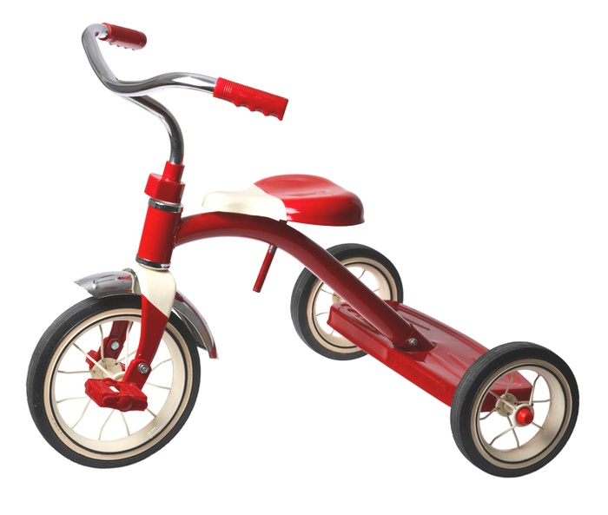
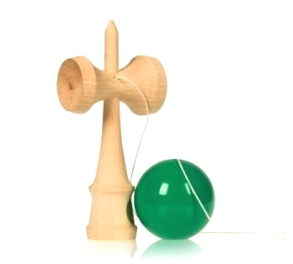
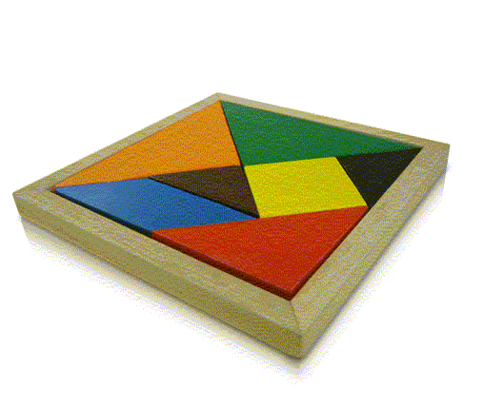

1
24
34
_ _ _ C _ _ _ _ _ _ _ G _ _ _ K _ _ _ _ _ _

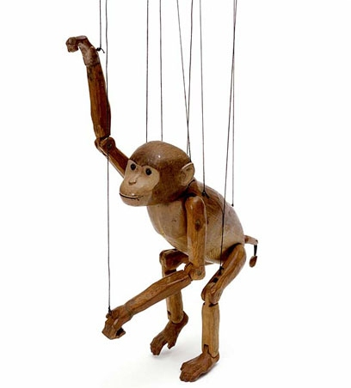

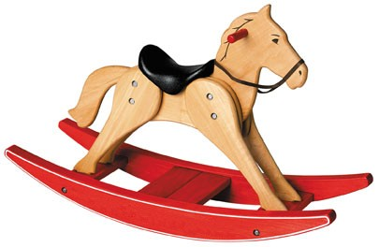

4
5
6
_ _ _ K _ _ _ _ _ _ _ _ _ _ _ _ _ T _ U _ _ _ _ _ _

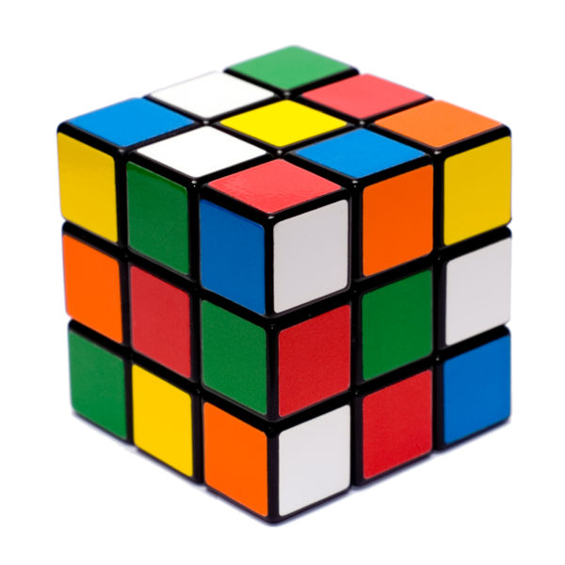
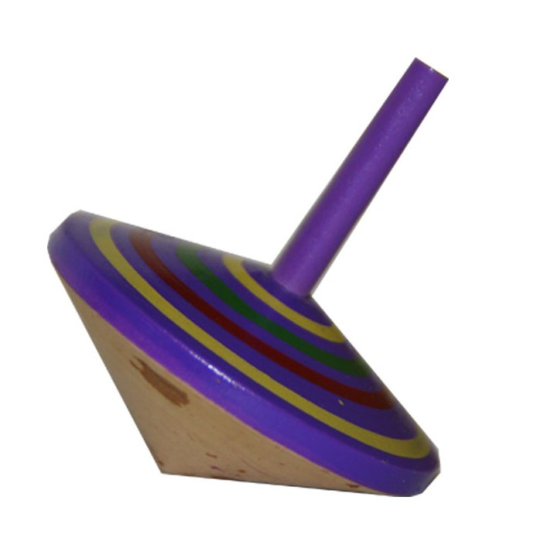
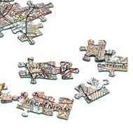

7
8
9

_ _ G _ _ _ _ _ _ _ _ _ _ _ _ _ _’S _ _ _ _ _ _ _ _ _ I _ _ _ _ _
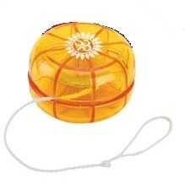
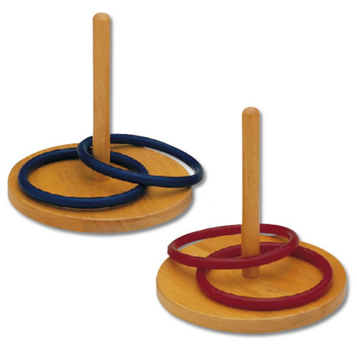
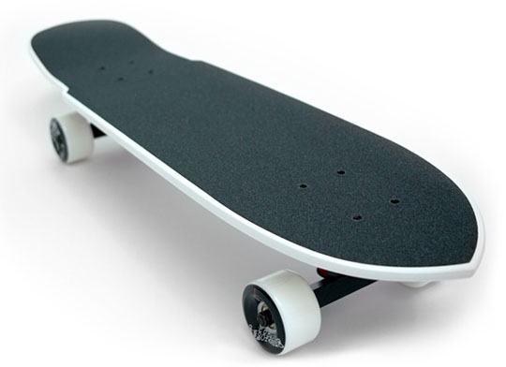

10
1208
11108

_ O-_ _ Q _ _ _ _ _ _ _ A _ _ _ _ _ _ _

Please send your entry to the Editorial Board of Word Power, Official Languages Division, Civil Service Bureau, Room 2310, High Block, Queensway Government Offices, 66 Queensway, Hong Kong before 12 August 2011. Watch out for our coming issue to see if you get all the answers right and, better still, if you are one of the lucky five to win a prize. The Editorial Board will have the final say on the answers.

Name : Mr/Mrs/Miss/Ms (delete as appropriate)
Department: Post:
Office Address:
Tel. No.:

Issue No. 45 (September 2011) : Man and Society
Issue No. 46 (December 2011) : Festivals and Rituals
二零一一年九月第四十五期主題：社會倫理
二零一一年十二月第四十六期主題：節日慶祭

Contributions from colleagues are welcome. Please refer to Issue No. 42 for details.
歡迎同事投稿，細則請參閱第四十二期。

中文顧問 康寶文博士 英語顧問 Dr Robert J. Neather
編輯委員會
主席 梅李碧燕女士 委員 楊何佩玲女士 執行編輯 陸景良先生
委員 陳璧君女士 委員 葉若碧女士 助理編輯 司徒嘉慧女士
委員 何維安先生 委員 張穎薇女士
委員 魯曼華女士 委員 江俊偉先生

Hon Chinese Adviser Dr Hong Po-man Hon English Adviser Dr Robert J. Neather
Editorial Board
Chairman Mrs Stella Mui Member Mrs Loletta Yeung Executive Editor Mr Kenneth Luk
Member Ms Peggy Chan Member Ms Iris Ip Assistant Editor Miss Cynthia Seto
Member Mr James Ho Member Ms Winnie Cheung
Member Miss Holly Lo Member Mr Damon Kong

《文訊》另載於公務員事務局網頁（http://www.csb.gov.hk/tc_chi/publication/2006.html）。如對本刊有任何意見或建議，請寄交香港金鐘道66號金鐘道政府合署高座2310室公務員事務局法定語文事務部《文訊》編輯委員會，或電郵至csbolrs@csb.gov.hk。

Word Power is also uploaded to the webpage of the Civil Service Bureau (http://www.csb.gov.hk/english/publication/2006.html). If you have any comments or suggestions about this publication, please write to the Editorial Board of Word Power (Official Languages Division, Civil Service Bureau, Room 2310, High Block, Queensway Government Offices, 66 Queensway, Hong Kong or csbolrs@csb.gov.hk).

